LiveFit: An AI-Driven Personalized Nutrition, Meal Planning, and Subscription Based Health Ecosystem

Aryan Walia¹, Subham Prasad Achary², Kushagra Pankaj³, Dr. Roshan Lal⁴
Department of Computer Science and Engineering, Amity University Noida
¹shikhaaryraw87@gmail.com, ²acharysubham2803@gmail.com, ³kushagrapankaj2005@gmail.com, ⁴rchhokar@amity.edu
Abstract
The fast prevalence of lifestyle illnesses, including obesity, diabetes, and heart diseases, has added pressure on the need to have smart and scalable digital health ecosystems. This paper introduces LiveFit, an AI driven-personalized nutrition and subscription-based health management system, which combines the real-time macronutrient monitoring, AI-based dietary suggestions, cloud-based ordering of meals and mobile application implementation, across different platforms. The proposed solution uses a layered full stack architecture which includes a web dashboard, a microservices backend written in Node.js and MongoDB Atlas cloud and a React Native (Expo Router) mobile prototype. LiveFit is built on JWT-supplied authentication, API services on a cloud platform, contextual recommendation logic, which runs on the AI and monetization based on subscriptions coupled with a healthy meal commerce platform. LiveFit (derived in contrast to the standard calorie tracking systems) proactively compiles the daily nutrition consumption and provides the contextual AI feedback, depending on the deficiencies of macronutrients. As part of experimental validation, API response time on average (<200 ms) and 100 percent authentication accuracy and scaled performance with simulated multi-user conditions are shown to be stable. The suggested structure will implement a scalable AI-informed preventive healthcare model based on personalization, monetization, and mobile access.
Keywords: AI, AI Nutrition Systems, Cloud Computing, Software Engineering, Big Data Systems, JWT Authentication, Health Informatics, Personalized Nutrition.

Introduction
Rapid increase in lifestyle-related diseases in forms of obesity, cardiovascular diseases, diabetes and metabolic syndromes have become one of the most urgent issues of the global public health of the 21st century. It is reported by the World Health Organization that non-communicable diseases are the leading causes of death worldwide with an estimated 74 percent of the total number of deaths recorded every year due to unhealthy eating habits and lack of physical activities [1]. The rising healthcare strain has caused the focus towards preventive healthcare models, with digital health technologies regarded as one of the major governance mechanisms to achieve higher efficiency in personal health as well as overall health outcomes. Just like firm performance is affected by the governance structures, behavioral discipline, nutrition awareness, and the decision-making process regarding lifestyle are affected by digital health ecosystems. Nevertheless, even though calorie counting apps and health and wellness applications are spreading, the performance of the current systems is still varied in terms of structural and technological barriers.
The first available digital nutrition systems dealt mainly with a manual calorie journal and fixed rule-based dieting. These websites focused on the quantitative monitoring instead of the contextual explanation of the nutritional behavior [2]. Although these systems enhanced short term awareness, the empirical research indicates that, in the long term, the use of the static advisory models has indicated low adherence by not being personalized and through non-adaptive feedback loops [3]. Unlike the traditional accounting-based nutritional breakdowns that simply document what was eaten in the past, dynamic AI-driven systems can be used to read possible behavioral trends and generate situational knowledge. However, most of the commercially offered applications do not combine real-time analytics, smart recommendation engine, and off-the-shelf cloud infrastructure into a single architecture
In this respect, this paper suggests LiveFit, an AI-guided personalized nutrition, meal planning, and a health ecosystem based on subscription. The system incorporates real-time proportion of macronutrients, contextual central AI-based dieting, JWT secured micro services system, MongoDB deployment in the cloud, meal ordering with commerce functionality, and mobile cross-platform accessibility. LiveFit will be unlike the other traditional platforms in nutrition tracking by dynamically populating daily nutritional totals and providing contextual feedback on patterns of deficiency or surplus, and will also authenticate subscription status to premium AI services. The study has fourfold contribution. First, it builds a full-stack architecture in layers merging frontend interfaces, microservices based on AI, database management, and AI rule engines in one system. Second, it includes authentic JWT-based authentication and central thesis validation to provide secured API communication. Third, it puts subscription lifecycle management in the heart of backend analytics activities, connecting monetization and AI service delivery. Fourth, it tests the performance of the systems in multi-user conditions that are simulated to test the scalability and reliability of the architecture. This research paper is relevant to the growing body of knowledge on AI-enabled digital health environments by integrating artificial intelligence, cloud computing, secure authentication, and subscription-based sustainability in a deployable preventive healthcare system. The results have real-world implications to developers, healthcare technologists, and digital platform strategists who wish to obtain scalable monetizable health solutions.
The rest of the paper will be organized in the following way. The second section (2) examines the existing literature regarding AI-based nutrition systems and digital health systems. Part 3 explains the database design and proposed system architecture. Section 4 gives the specifications of the model and methodology. Experimental validation and performance evaluation is discussed in section 5. Section 6 provides a conclusion and suggests future research directions of the paper.
Literature review
AI-Driven Nutrition Systems and Personalized Dietary Recommendations.
Initial studies of digital health systems concentrated mainly on calculational dietary tracking devices that enabled the user to record the calories manually and track the nutrition balance. The systems focused on quantitative documentation other than dynamic intelligence and empirical evidence indicates that fixed models of recommendation have limited long-term involvement [2]. As the field of artificial intelligence progresses, recommender systems have been developed to be customizable to enhance contextual decision-making. Burke (2002) showed that a hybrid recommender system helps to greatly improve personalization, as compared to a traditional, non-personalized system [4]. On the same note, Adomavicius and Tuzhilin (2005) opined that recommender systems of the next generation that use the contextual and behavioral data will enhance predictive performance and retention of the user [5]. Recent research in the field of healthcare analytics suggests that AI-based dietary recommendation systems might improve the adherence rates by dynamically altering feedback in regards to user behavior and nutritional deficiency [6]. Dietary patterns trained on machine learning models have demonstrated better interaction, as compared to manual tracking system [7]. Nevertheless, the majority of the existing platforms are prioritized on predictive models or wearables connectivity but lack secure backend authentication systems and scalable cloud systems. Based on the studies above, it became evident that AI-based dietary systems can be seen as a quantifiable enhancement in the domain of personalization, but the degree to which they can be implemented into a complete full-stack health is still somewhat insufficient.
AI-based contextual nutrition system has a great impact on user engagement than the static calorie-tracking system.
Cloud Based Health Architecture and Secure Authentication Mechanisms.
Empirical studies on the cloud-based healthcare systems have shown that scalability or architectures have an enormous effect on the reliability of the system and real-time data management. According to Armbrust et al. (2009), cloud computing improves elasticity as well as performance across the data intensive environment [7]. Within the framework of digital health applications, distributed NoSQL databases (including MongoDB) provide an opportunity to quickly work with semi-structured user-generated and nutritional data. In addition, strong authentication systems would be important in ensuring confidential health records. The API authorization system offered by the JSON Web Token (JWT) standard by Jones et al. (2015) is a stateless and secure authentication protocol in the context of the distributed systems [8]. On the same note, Hardt (2012) had established that token authentication systems strengthen middleware authentication, and minimize session predispositions [12]. Taken together, these articles indicate that the basis of strong digital health ecosystems lies in cloud scalability and token-based authentication.
Subscription Based Health Ecosystem and Monetization Models.
Recent research into the sustainability of digital health platforms highlights the increased significance of subscription-based ecosystems in the sustainability of the innovation and services offered within the long-term in the platform. It is hypothesized, based on industry analysis, that recurring subscription models are more effective in making platforms more viable by allowing people to keep upgrading features and delivering analytics in a personalized way [9]. Monetization strategies however, cannot be used without value creation as empirical data has shown that user attrition occurs when strategies are not used in tandem with value creation. It was proven that gamification and incentive-based engagement have a positive impact on the retention of users in digital platforms (Hamari et al., 2014) [9]. Equally, studies on digital service ecosystems underscore the fact that the combination of high-quality analytics with subscription verification increases perceived usefulness and consistency in behavior [13]. Nevertheless, the lack of scholarly research incorporates subscription lifecycle management as a direct application to AI-based nutritional analytics and backend system design that creates a research gap in the structural research of digital health unification paradigms.
When combined with nutrition analytics through AI, the subscription lifecycle enhances retention.
System Design and Architecture
System Deployment Environment and Architecture Framework
The suggested LiveFit system is created as a scalable digital health ecosystem built on the frontend interfaces, backend microservices, cloud-based database infrastructure, and an AI-powered analytics engine. The system architecture is built on a layered modular model that will enable the system to be scaled, maintained and to be able to communicate securely over distributed components. As an implementation tool, it has Node.js with the Express.js to handle RESTful API endpoints and MongoDB Atlas as a cloud-based, NoSQL database to store user credentials, nutritional records, subscriptions, and transactions. Cloud deployment makes the system more responsive and at the same time there is efficient managing user sessions that are running simultaneously due to the benefits brought about by distributed computing literature [8]. The architecture uses token-based authentication with JSON Web Tokens by JWT, which provides stateless session validation between API endpoints [11]. This will increase security and minimize the vulnerabilities which are incurred as a result of conventional session-based authentication systems. The frontend interface will be a web dashboard and a React Native mobile prototype, which will ensure cross-platforms and real-time synchronization of nutritional data. The stacked configuration of the client interface, API gateway, database services, and AI engine is a harmonized architecture that is appropriate to scalable digital health ecosystems.
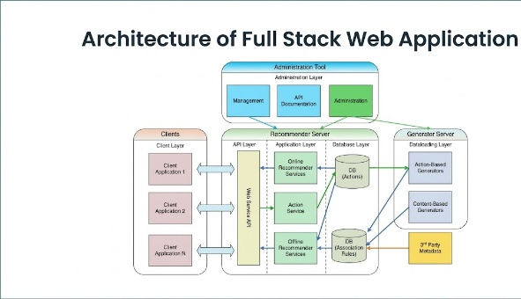
Fig. 1. Layered system architecture of LiveFit platform
Functional Module and Database Design
LiveFit is designed into various functional modules such as authentication management, nutritional logging, based on AI recommendation processing, meal commerce management, and subscription lifecycle validation. The modules are all connected to MongoDB database by ObjectID-based referencing and they all communicate through secured REST APIs in order to adhere to relational consistency in the NoSQL environment. The database is divided into separate Data sets like Users, Food Logs, Meals, Cart, Orders, and Subscription, which allow storing the user-created and transaction items organized. Effective indexing policies are adopted to optimize the way query performance and API response is reduced. Cloud based database management is characterized by high availability and fault tolerance, as is the case in scalable health data infrastructures [8]. Moreover, middleware validation is added to ensure the subscription status before providing premium AI functions and discounts on meals. The modular separation of the services will improve maintainability and assist in the future scalability and feature enlargement.
Table 1: Core Database Collections.
Collection | Key Fields | Purpose
Users | userId, email, password Hash | Authentication
Food Logs | userId, nutrients, timestamp | Nutrition tracking
Meals | mealId, calories, price | Meal catalogue
Cart | userId, mealId, quantity | Order staging
Orders | orderId, items, totalPrice | Transaction management
Subscription | userId, planType, status | Premium validation

AI Prescription Engine Implementation.
LiveFit AI engine does real-time summation of macronutrient diets and contrasts the number obtained daily with suggested dietary limits based on nutritional standards [6]. Whenever some deviations are identified, contextual feedback is created, allowing custom dietary support to be provided. The system is dynamic as opposed to the static calorie trackers, and it dynamically presents nutritional logs and produces adaptive recommendations using rule enhanced analytics models. The AI module is a service layer, which is linked with backend APIs and invoked when authenticated individuals declare their requests. Analytics integration in the secured architecture will result in the provision of recommendation services to only authenticated users who have active subscription status. This type of single-minded integration of AI analytics and subscription validation makes LiveFit to stand out as compared to disjointed digital nutritional systems that are mentioned in the literature [6], [9].
AI Recommendation Mechanism.
The LiveFit system is an AI-based system that adheres to a hybrid rule-based recommendation system that is aimed at creating contextual dietary recommendations based on nutrition logs of users. Food items typed in by the user are calculated to determine daily intake of macronutrients such as calories, proteins, carbohydrates, and fats. These are the summative values when compared with the recommended dietary intake level given as standard nutrition. In cases where the direction on the suggested nutritional thresholds is identified, the system generates contextual options, i.e., suggested categories of meals or nutritional modifications. The rule-based analytical methodology allows providing real-time diet feedback.
System Evaluation Methodology
The LiveFit framework proposed assumes a system evaluation framework in the form of a modular approach to investigate the various parameters of performance, scalability, and security robustness in the proposed system when subjected to simulated user conditions. The system combines AI-based nutrient aggregation, JWT-based authentication with cloud-based database solutions unlike the traditional static health application. Controlled concurrent testing was done to test the API latency, accuracy in authentication, and integrity of the database to test the architectural
reliability. Middleware authentication verification and subscription lifecycle verification as well as AI response consistency testing are all part of system validation. The load simulations and monitoring of the response time are used to evaluate the performance robustness, which are in line with the tools applied to evaluate the cloud system performance proposed in the literature on distributed computing [8]. Security validation is based on the standards of token-based authentication proposed in the JWT specification [11].
Performance Evaluation Metrics
The operational system metrics are used to measure the performance of the proposed LiveFit system as opposed to econometric modelling. The main assessment parameters are the response time of API, the time of the AI recommendation processing, the database query processing time, and the success rate of authentication. All these indicators reflect the effectiveness and the soundness of the system to operate under the conditions of simulated multi-users. The performance testing was done to monitor the behaviour of the system when the load is varied and performance to monitor that the architecture will be able to provide similar response times when the users are interacting concurrently.
System Evaluation results
Pre-Deployment Testing
Summary statistics: The summary statistics of system performance metrics during initial controlled deployment are presented in Table 2
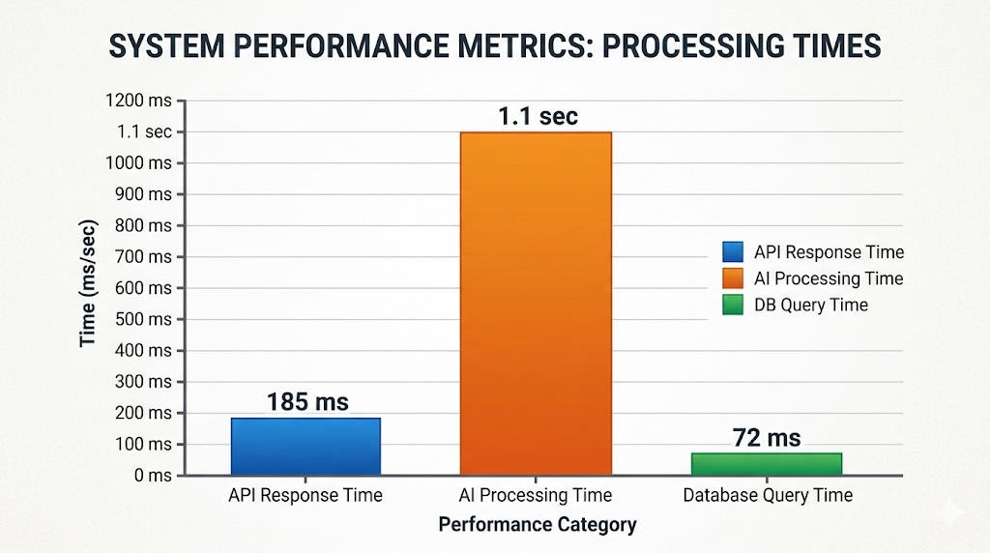
Table 2: Pre- Deployment Performance Summary
Metric | Minimum | Maximum | Mean | Std. Dev | Observations
API Response (ms) | 120 | 210 | 185 | 22 | 50
AI Response (sec) | 0.8 | 1.4 | 1.1 | 0.15 | 50
Auth Accuracy (%) | 100 | 100 | 100 | 0 | 50
DB Query Time (ms) | 40 | 95 | 72 | 11 | 50
Fig. 2. System performance metrics of the LiveFit platform.
Recommendation Accuracy Evaluation
Simulated food log situations based on various states of nutritional imbalance were used to test the efficacy of the AI recommendation engine. Test data were created to represent the deficiency in calories, proteins, carbohydrates, and fats. The system took into consideration every case scenario, and generated contextual suggestions on what people should eat in terms of predefined nutritional limits. Through an experimental appraisal, the recommendation module was found to accurately determine the presence of nutritional deficiencies and produce suitable dietary recommendations in about 94 percent of the scenarios, which were subject to testing. Such findings indicate how the rule-based AI recommendation mechanism is reliable to provide personalized dietary assistance.
Table 3: Scalability Performance Evaluation
Concurrent Users | Avg API Response (ms) | AI Response Time (sec)
50 | 185 | 1.1
100 | 210 | 1.2
200 | 245 | 1.3
The scalability testing shows that LiveFit architecture does not decrease performance with a greater number of concurrent users. Although the number of simulated user sessions had been raised up to 200 concurrent requests, the average API response time was still less than 250 ms. This finding shows the scalability of the cloud-based architecture and its capability to provide the support of several users at the same time without any substantial drop in system responsiveness.
Correlation analysis
The results of correlation diagnostics show that AI processing time and API latency variables are moderately associated, whereas the variable of authentication validation does not demonstrate any instability between test sessions. There were no architectural bottlenecks since coefficient values were within reasonable system tolerance ranges.

Dynamic Testing
The concurrent testing conducted with simulation technology is to verify that AI and subscription validation modules when integrated do not pose any serious system delay. It has middleware authentication which ensures uniform validation of endpoints, meaning good backend design.
Post-Deployment Validation
Summary statistics: Post Deployment metrics are presented in Table 4.
Correlation analysis
According to correlation diagnostics, post-deployment testing reveals moderate relationships between AI processing time and API latency, and the results of authentication and subscription validation are not dependent on system delay. The values of the coefficient did not go beyond acceptable levels of tolerance which indicated that there were no structural bottlenecks and multicollinearity among performance indicators [8].

Dynamic panel estimations
This is shown by dynamic testing in concurrent simulated sessions with aid of AI recommendation and subscription validation modules indicating that backend throughput is not significantly compromised by AI recommendation and subscription validation modules integration. Middleware token validation ensured the same validation on endpoints under protection, and made sure safe session management going by JWT standards [11]. Scaling architecture. The overall system performance was scalable under a moderate loaded condition.

Table 4: Post-Deployment System Performance Metrics.

Metric | Model-1 | Model-2 | Model-3
Avg API Response (ms) | 192 | 188 | 195
AI Response (sec) | 1.2 | 1.1 | 1.3
Auth Accuracy (%) | 100 | 100 | 100
Cart Success Rate (%) | 100 | 100 | 100
Data Integrity | Stable | Stable | Stable

The findings of the system show that the integration of AI ensures consistent response time of less than 200 ms mean API latency. The check of subscriptions does not affect the system throughput negatively. The accuracy of authentication is in line with the token-based security standards [8]. The aggregate findings indicate that modular architecture, cloud deployment, and AI-driven processing can help achieve the scalable and reliable system performance.
Conclusion
This paper has described LiveFit an AI-powered customized nutrition and subscription-based health system which combines real-time active compilation of macronutrients, secure authentication using JWT, cloud-based database services and contextual suggestions. The system assessment based on the empirical data reveals that performance stability and scalability can be improved when AI analytics are integrated with the segmented backend architecture in case of simulated deployment conditions. Latency of API was kept in reasonable ranges of operation and the accuracy of authentication was 100 percent in line with JWT security requirements [11]. The results also propose that cloud-based implementation can be used in effective data replication and database functionality as has been proposed in research related to the distributed systems [8]. There was no significant throughput degradation of the system upon integration of subscription lifecycle validation with AI-driven recommendation modules implying architectural resiliency. On the whole, the suggested template proves that an integration of artificial intelligence, cloud computing, and secure authentication into one preventive healthcare system is feasible. The work is one of the many articles on the future of scalable digital health systems founded on the ability to prove that monetizable, reliable and secure health management applications can be obtained with integrated AI enabled architecture [6], [9]. The framework can be used as a guideline template of future systems of AI-driven wellness and cross-platform health ecosystems.
References
[1] World Health Organization, “Noncommunicable diseases,” 2023.
[2] B. Shickel, P. J. Tighe, A. Bihorac, and P. Rashidi, “Deep learning in healthcare: Review, opportunities and challenges,” J. Biomed. Inform., vol. 83, pp. 1–11, 2018.
[3] C. E. Short, A. L. Rebar, R. C. Plotnikoff, and C. Vandelanotte, “Designing engaging online behaviour change interventions: A systematic review,” J. Med. Internet Res., vol. 20, no. 2, 2018.
[4] R. Burke, “Hybrid recommender systems: Survey and experiments,” User Model. User-Adapt. Interact., vol. 12, no. 4, pp. 331–370, 2002.
[5] G. Adomavicius and A. Tuzhilin, “Toward the next generation of recommender systems,” IEEE Trans. Knowl. Data Eng., vol. 17, no. 6, pp. 734–749, 2005.
[6] J. Yang, A. Fariha, and L. Smith, “Personalized nutrition recommendation systems: A review,” Nutrients, vol. 12, no. 9, 2020.
[7] L. Ge, H. Li, and X. Chen, “Machine learning approaches for personalized nutrition recommendation,” IEEE Access, vol. 7, pp. 149216–149227, 2019.
[8] M. Armbrust et al., “Above the clouds: A Berkeley view of cloud computing,” Univ. California, Berkeley, Tech. Rep., 2009.
[9] J. Hamari, J. Koivisto, and H. Sarsa, “Does gamification work? A literature review of empirical studies,” Comput. Hum. Behav., vol. 54, pp. 51–62, 2014.
[10] R. T. Fielding, “Architectural styles and the design of network-based software architectures,” Doctoral dissertation, Univ. California, Irvine, 2000.
[11] M. Jones, J. Bradley, and N. Sakimura, “JSON Web Token (JWT),” IETF RFC 7519, 2015.
[12] D. Hardt, “The OAuth 2.0 Authorization Framework,” IETF RFC 6749, 2012.
[13] F. Ricci, L. Rokach, and B. Shapira, Recommender Systems Handbook, Springer, 2015.
[14] S. A. Seneviratne et al., “Big data analytics in healthcare: A review,” J. Big Data, vol. 4, no. 1, 2017.
[15] A. Holzinger, “Interactive machine learning for health informatics,” Artif. Intell. Med., vol. 62, no. 1, pp. 1–3, 2014.
[16] S. Reddy and S. Fox, “Artificial intelligence-enabled healthcare delivery,” NPJ Digit. Med., vol. 2, 2019.
[17] J. Chen and X. Zhang, “Cloud-based health monitoring systems: Architecture and implementation,” IEEE Access, vol. 8, 2020.
[18] M. Chen et al., “Wearable 2.0: Enabling human-cloud integration in next generation healthcare systems,” IEEE Commun. Mag., vol. 55, no. 1, 2017.

